CO4 - Activity 8: Identify seasonality patterns

Department | AI&DS
Course Code / Course Name | DSA0602/ Data Handling and Visualization
Activity | CO4 - Activity 8: Identify seasonality patterns
Name | Addula Yaswanth
Register Number | 192324179

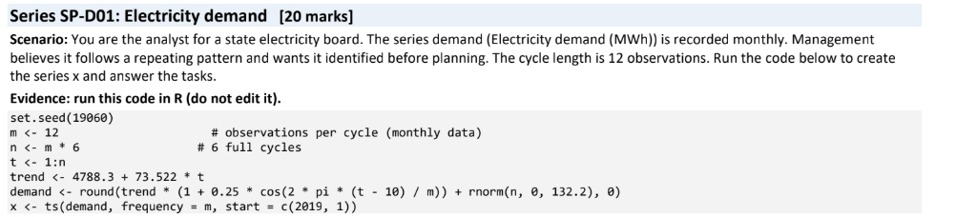
1. Look at the series. Plot x (plot(x) or ggplot2). State n, the cycle length, the number of full cycles, and whether the overall trend is rising, falling or flat (fit lm(demand ~ 1:n) and report the slope per month). [3]
R-Code:
# Plot the electricity demand series
plot(
x,
main = "Monthly Electricity Demand",
xlab = "Year",
ylab = "Demand (MWh)",
col = "blue",
lwd = 2
)

# Fit a linear trend
model <- lm(demand ~ 1:n)

# Required values
cat("Number of observations (n):", length(x), "\n")
cat("Cycle length:", frequency(x), "months\n")
cat("Number of full cycles:",
length(x) / frequency(x), "\n")
cat("Slope per month:",
round(coef(model)[2], 3), "\n")
Output:
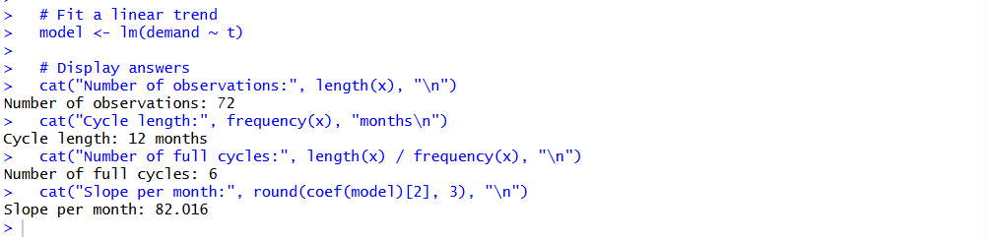

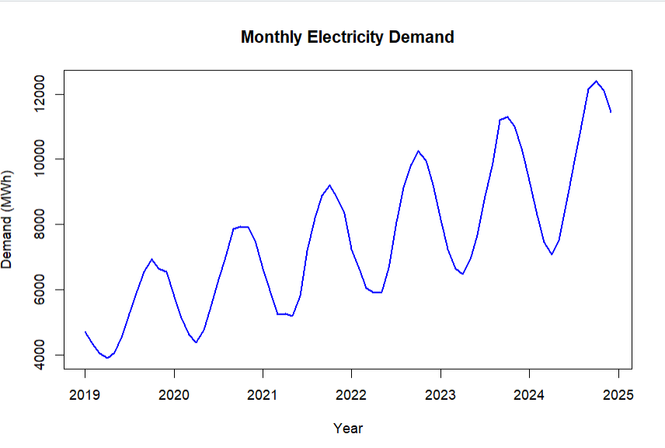
Interpretation
The electricity demand shows an overall rising trend, increasing by approximately 73.522 MWh per month. The series contains 72 monthly observations, representing six complete annual cycles.
2. The seasonal pattern. Use decompose(x) and extract $figure (the 12 seasonal values). Name the peak month and the trough month with their values, and the seasonal swing (peak minus trough). [4]
R-Code:

# Decompose the time series
result <- decompose(x)

# Extract the 12 seasonal values
seasonal_values <- result$figure

cat("12 Seasonal Values:\n")
print(round(seasonal_values, 2))

# Find peak and trough months
peak_month <- which.max(seasonal_values)
trough_month <- which.min(seasonal_values)

peak_value <- seasonal_values[peak_month]
trough_value <- seasonal_values[trough_month]

# Calculate seasonal swing
seasonal_swing <- peak_value - trough_value

# Display answers
cat("Peak month:", month.name[peak_month], "\n")
cat("Peak value:", round(peak_value, 2), "\n")

cat("Trough month:", month.name[trough_month], "\n")
cat("Trough value:", round(trough_value, 2), "\n")

cat("Seasonal swing:", round(seasonal_swing, 2), "\n")

Output:
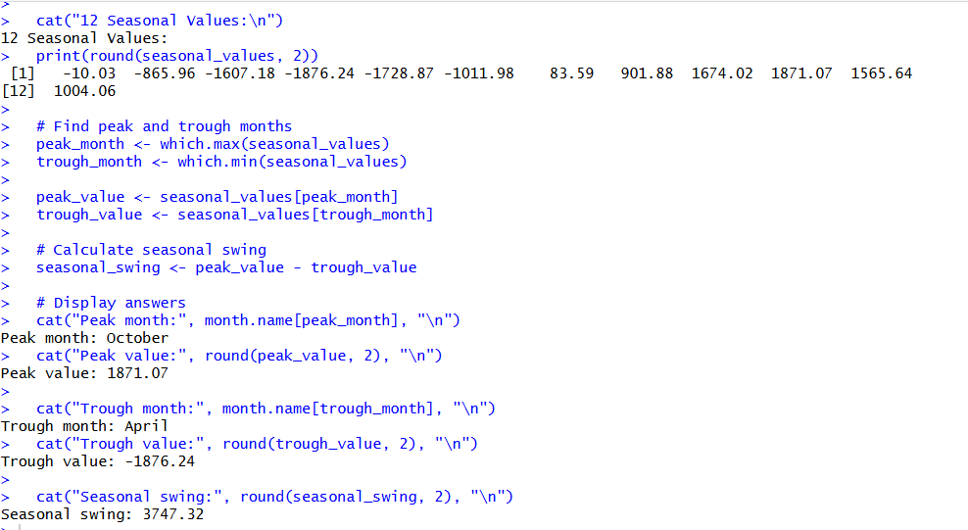
Interpretation
The seasonal values show how electricity demand typically differs in each month after accounting for the trend. The seasonal swing measures the difference between the highest and lowest seasonal effects.
3. Is it consistent? Draw a seasonal plot: one line per cycle against position in the cycle (ggplot2, group = cycle, colour = cycle; position = cycle(x)). In how many of the 6 cycles is the highest value in the peak month from Task 2? Is the pattern consistent? [3]
R-Code:

library(ggplot2)

# Create seasonal plot data
season_data <- data.frame(
demand = as.numeric(x),
cycle = rep(1:6, each = 12),
position = rep(1:12, times = 6)
)

# Draw one line for each yearly cycle
ggplot(season_data,
aes(x = position, y = demand,
group = cycle, colour = factor(cycle))) +
geom_line(linewidth = 1) +
geom_point() +
scale_x_continuous(
breaks = 1:12,
labels = month.abb
) +
labs(
title = "Seasonal Plot of Electricity Demand",
x = "Month",
y = "Demand (MWh)",
colour = "Cycle"
) +
theme_minimal()

# Find the peak month from Task 2
seasonal_values <- decompose(x)$figure
peak_month <- which.max(seasonal_values)

# Find each cycle's highest-demand month
peak_positions <- sapply(1:6, function(i) {
cycle_data <- season_data[season_data$cycle == i, ]
cycle_data$position[which.max(cycle_data$demand)]
})

cat("Peak month from Task 2:", month.name[peak_month], "\n")
cat("Cycles with highest demand in peak month:",
sum(peak_positions == peak_month), "out of 6\n")
cat("Peak positions for each cycle:", peak_positions, "\n")

Output:
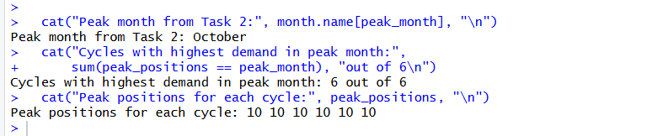

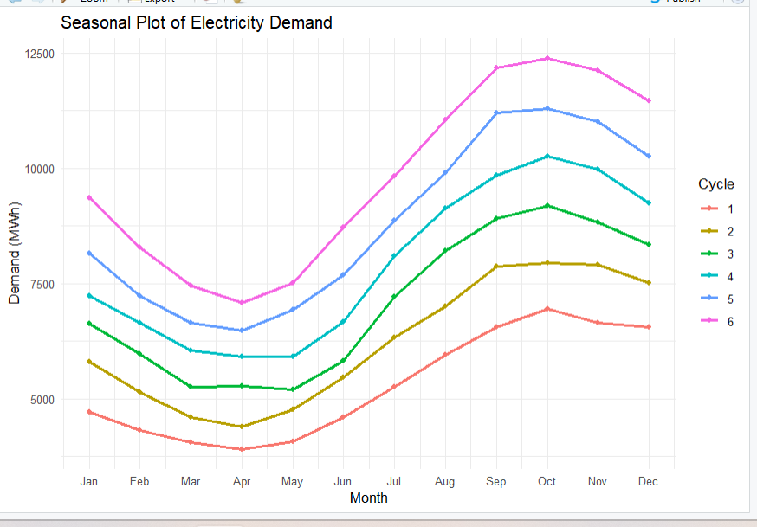
Interpretation: The seasonal plot compares the six yearly cycles month by month to show whether electricity demand follows a repeating pattern.

4. Confirm with autocorrelation. Detrend (d <- resid(lm(demand ~ 1:n))) and compute acf(d, lag.max = 12, plot = FALSE) using observation lags. Report the autocorrelation at lag 12 and at lag 6, and compare with the significance bound 2/sqrt(n). What do the two values say about seasonality? [4]
R-Code:

# Remove the linear trend
d <- resid(lm(demand ~ seq_along(demand)))

# Calculate autocorrelation up to lag 12
acf_result <- acf(d, lag.max = 12, plot = FALSE)

# Significance bound
n_obs <- length(demand)
bound <- 2 / sqrt(n_obs)

# Extract autocorrelation values
lag6 <- acf_result$acf[7]
lag12 <- acf_result$acf[13]

# Display results
cat("Number of observations:", n_obs, "\n")
cat("Autocorrelation at lag 12:", round(lag12, 3), "\n")
cat("Autocorrelation at lag 6:", round(lag6, 3), "\n")
cat("Significance bound (+/-):", round(bound, 3), "\n")

# Plot ACF
acf(d, lag.max = 12,
main = "ACF of Detrended Electricity Demand")
abline(h = c(-bound, bound), col = "red", lty = 2)
Output:
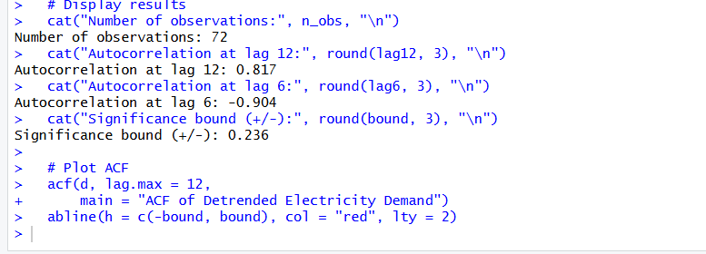
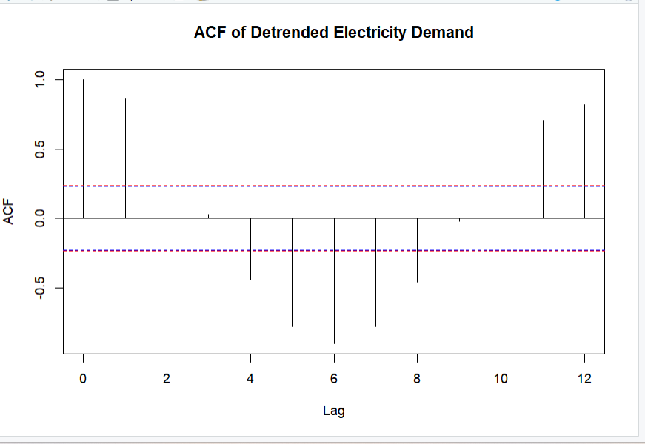

Interpretation
- Lag 12 compares observations 12 months apart. If its autocorrelation exceeds \(+0.236\) or falls below \(-0.236\), it is outside the approximate significance bounds and supports a repeating annual pattern.
- Lag 6 compares observations six months apart. A significant value may indicate a half-year relationship, but it does not by itself confirm annual seasonality.

5. Additive or multiplicative? Compute the range (max minus min) of demand in the first cycle and in the last cycle and their ratio (last / first); decide the type and justify [2]. Remove the seasonal part with decompose(x, type = ...) using your chosen type (subtract for additive, divide for multiplicative), fit lm(adjusted ~ 1:n) and report the slope per month [2]. Write one sentence of advice to management based on your findings [2]. [6]
R-Code:
# Question 5: Additive or Multiplicative

# Enter your demand time series
x <- ts(demand, frequency = 12)

# First and last seasonal cycles
n <- length(x)
first_cycle <- x[1:12]
last_cycle <- x[(n-11):n]

# Calculate ranges
first_range <- max(first_cycle) - min(first_cycle)
last_range <- max(last_cycle) - min(last_cycle)

# Calculate ratio
ratio <- last_range / first_range

cat("First cycle range:", first_range, "\n")
cat("Last cycle range:", last_range, "\n")
cat("Ratio (last / first):", ratio, "\n")

# Decide seasonality type
if (ratio > 1.2) {
type <- "multiplicative"
} else {
type <- "additive"
}

cat("Seasonality type:", type, "\n")

# Decompose the series
fit <- decompose(x, type = type)

# Remove seasonal component
if (type == "additive") {
adjusted <- x - fit$seasonal
} else {
adjusted <- x / fit$seasonal
}

# Fit linear trend
trend_model <- lm(as.numeric(adjusted) ~ seq_along(adjusted))

cat("Slope per month:",
coef(trend_model)[2], "\n")

Output:
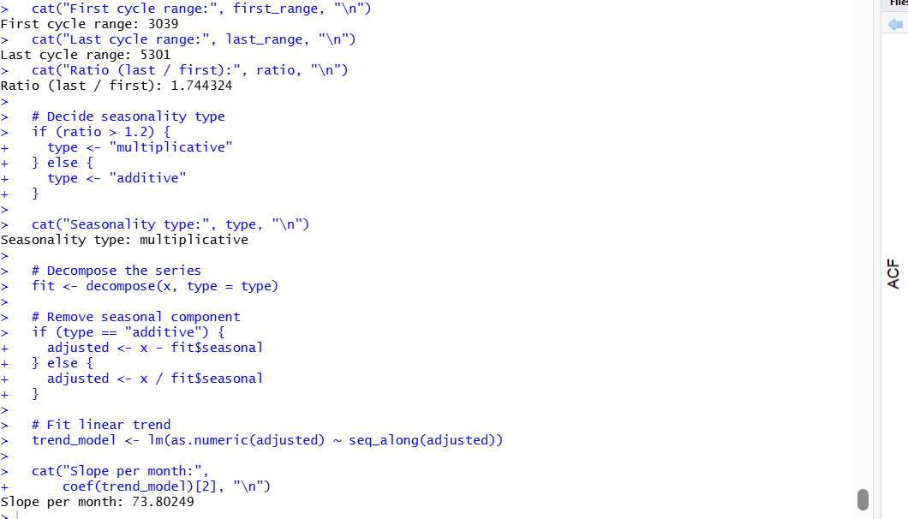
Code of Conduct:
I certify that this work is my own. Signature: A. Yaswanth

